**Technical Problem Share [15/04/2020]**

Edit by Liu Yuancheng

1. **Problem**

Type: Python network communication.

Description: ICMP message caused the echo-UDP server raise exception.

1. **Problem Back Ground**

We created a UDP data update client and the echo data handling server lib module by python-3.7.4. The server will call the plugged in method to auto response the client’s request if the client’s <sendMsg()> response flag was set to True

This is the client and server module program:

Git hub link: <https://github.com/LiuYuancheng/ProgramTools/blob/master/socketComm/src/udpCom.py>

#!/usr/bin/python

#-----------------------------------------------------------------------------

# Name:        udpCom.py

#

# Purpose:     This module will provide a UDP client and server communication API.

#

# Author:      Yuancheng Liu

#

# Created:     2019/01/15

# Copyright:

# License:

#-----------------------------------------------------------------------------

import time

import socket

BUFFER_SZ = 4096    # UDP buffer size.

RESP_TIME = 0.01

#-----------------------------------------------------------------------------

#-----------------------------------------------------------------------------

class udpClient(object):

    """ UDP client module."""

    def __init__(self, ipAddr):

        """ Create an ipv4 (AF_INET) socket object using the udp protocol (SOCK_DGRAM)

            init example: client = udpClient(('127.0.0.1', 502))

        """

        self.ipAddr = ipAddr

        self.client = socket.socket(socket.AF_INET, socket.SOCK_DGRAM)

#--udpClient-------------------------------------------------------------------

    def sendMsg(self, msg, resp=False, ipAddr=None):

        """ Convert the msg to bytes and send it to UDP server.

            - resp: server response flag, method will wait server's response and

                return the bytes format response if it is set to True.

        """

        if not ipAddr is None: self.ipAddr = ipAddr  # reset ip address.

        if self.client is None: return None # Check whether disconnected.

        if not isinstance(msg, bytes): msg = str(msg).encode('utf-8')

        self.client.sendto(msg, self.ipAddr)

        if resp:

            try:

                self.client.settimeout(20)

                data, _ = self.client.recvfrom(BUFFER_SZ)

                return data

            except ConnectionResetError as error:

                print("udpClient: Can not connect to the server!")

                print(error)

                self.disconnect()

                return None

        return None

#--udpClient-------------------------------------------------------------------

    def disconnect(self):

        """ Send a empty logout message and close the socket."""

        self.sendMsg('123', resp=False)

        time.sleep(RESP_TIME)# sleep very short while before close the socket to \

        # make sure the server have enought time to handle the close method, when \

        # server computer is fast, this is not a problem.

        # Call shut down before close: https://docs.python.org/3/library/socket.html#socket.socket.shutdown

        self.client.shutdown(socket.SHUT_RDWR)

        self.client.close()

        self.client = None

#-----------------------------------------------------------------------------

#-----------------------------------------------------------------------------

class udpServer(object):

    """ UDP server module."""

    def __init__(self, parent, port):

        """ Create an ipv4 (AF_INET) socket object using the tcp protocol (SOCK_STREAM)

            init example: server = udpServer(None, 5005)

        """

        self.server = socket.socket(socket.AF_INET, socket.SOCK_DGRAM)

        self.server.bind(('0.0.0.0', port))

        self.terminate = False  # Server terminate flag.

#--udpServer-------------------------------------------------------------------

    def serverStart(self, handler=None):

        """ Start the UDP server to handle the incomming message."""

        while not self.terminate:

            data, address = self.server.recvfrom(BUFFER_SZ)

            print("Accepted connection from %s" % str(address))

            msg = handler(data) if not handler is None else data

            if not msg is None:  # don't response client if the handler feed back is None

                if not isinstance(msg, bytes): msg = str(msg).encode('utf-8')

                self.server.sendto(msg, address)

        self.server.close()

#--udpServer-------------------------------------------------------------------

    def serverStop(self):

        self.terminate = True

#-----------------------------------------------------------------------------

#-----------------------------------------------------------------------------

# Test case program: udpComTest.py

This is the Library module test-Case program:

Github link:

<https://github.com/LiuYuancheng/ProgramTools/blob/master/socketComm/src/udpComTest.py>

#!/usr/bin/python

#-----------------------------------------------------------------------------

# Name:        udpComTest.py

#

# Purpose:     This module will provide a muti-thread test case program to test

#              the UDP communication modules by using port 5005.

#

# Author:      Yuancheng Liu

#

# Created:     2019/01/15

# Copyright:

# License:

#-----------------------------------------------------------------------------

import time

import threading    # create multi-thread test case.

import udpCom

UDP_PORT = 5005

#-----------------------------------------------------------------------------

#-----------------------------------------------------------------------------

class testThread(threading.Thread):

    """ Thread to test the UDP server/insert the tcp server in other program."""

    def __init__(self, parent, threadID, name):

        threading.Thread.__init__(self)

        self.threadName = name

        self.server = udpCom.udpServer(None, UDP_PORT)

    def msgHandler(self, msg):

        """ The test handler method passed into the UDP server to handle the

            incoming messages.

        """

        print("Incomming message: %s" %str(msg))

        return msg

    def run(self):

        """ Start the udp server's main message handling loop."""

        print("Server thread run() start.")

        self.server.serverStart(handler=self.msgHandler)

        print("Server thread run() end.")

        self.threadName = None # set the thread name to None when finished.

    def stop(self):

        """ Stop the udp server. Create a endclient to bypass the revFrom() block."""

        self.server.serverStop()

        endClient = udpCom.udpClient(('127.0.0.1', UDP_PORT))

        endClient.disconnect()

        endClient = None

#-----------------------------------------------------------------------------

#-----------------------------------------------------------------------------

def testCase(mode):

    print("Start UDP client-server test. test mode: %s \n" % str(mode))

    tCount, tPass = 0, True  # test fail count and test pass flag.

    if mode == 1:

        print("Start the UDP Server.")

        servThread = testThread(None, 0, "server thread")

        servThread.start()

        print("Start the UDP Client.")

        client = udpCom.udpClient(('127.0.0.1', UDP_PORT))

        # test case 0

        print("0. HearBeat message test:\n----")

        tPass = True

        for i in range(3):

            msg = "Test data %s" %str(i)

            result = client.sendMsg(msg, resp=True)

            tPass = tPass and (msg.encode('utf-8') == result)

        if tPass: tCount += 1

        print("Test passed: %s \n----\n" % str(tPass))

        # test case 1

        print("1. Client disconnect test:\n----")

        tPass = True

        client.disconnect()

        client = None

        try:

            client.sendMsg('Testdata', resp=True)

            tPass = False

        except:

            tPass = True

        if tPass: tCount += 1

        print("Test passed: %s \n----\n" % str(tPass))

        # test case 2

        print("2. Server stop test:\n----")

        servThread.stop()

        time.sleep(1)  # wait 1 second for all the sorcket close.

        tPass = (servThread.threadName is None)

        if tPass: tCount += 1

        print("Test passed: %s \n----\n" % str(tPass))

        # test case 3

        print("3. Client timeout test:\n----")

        client = udpCom.udpClient(('127.0.0.1', UDP_PORT))

        resp = client.sendMsg('Testdata', resp=True)

        tPass = (resp is None)

        if tPass: tCount += 1

        print("Test passed: %s \n----\n" % str(tPass))

        print(" => All test finished: %s/4" % str(tCount))

        client = servThread = None

    else:

        print("Add more other exception test here.")

#-----------------------------------------------------------------------------

if __name__ == '__main__':

    testCase(1)

In out UDP client program, when we want to disconnect from the server, we will send a disconnect message first (to make it simple to track currently we use str ‘123’), then we shutdown and close the socket. But if we don’t sleep a shot while(0.001Sec) as below:

    def disconnect(self):

        """ Send a empty logout message and close the socket."""

        self.sendMsg('123', resp=False)

        time.sleep(RESP_TIME) <= Without this line, there will be a error !

        self.client.shutdown(socket.SHUT_RDWR)

        self.client.close()

        self.client = None

The server’s recvFrom() method will report a **ConnectionResetError**:

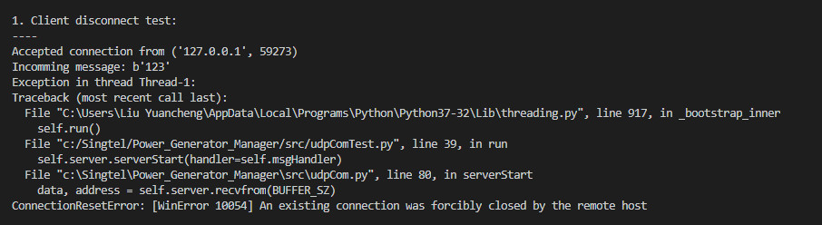

As the socket has be closed, logically there should not anything send from the client to the server, and UDP is “one way” communication.

1. **Problem Test Case Program**

Copy <udpCom.py> and <udpComtest.py> in same folder and run:

$ python udpComtest.py

1. **Problem Analysis**

Based on the exception message, we guess there must be some unexpected message got to the server side. So we try to use wireShark to capture the traffic:

* Normal Case:

This is the wireShark captured network communication between client and server when we call sleep() to make the program wait a short while (no exception):

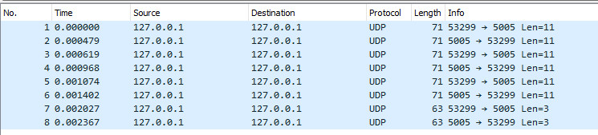

* Exception Case:

This is the captured network communication between client and server when we don’t call sleep ():

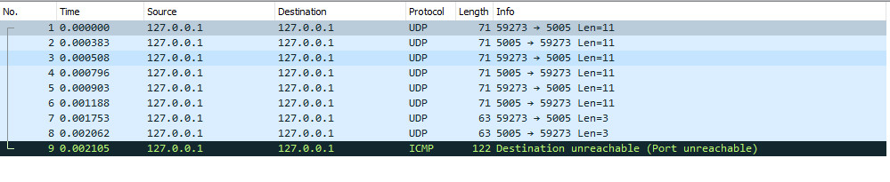

We can see there is an additional ICMP protocol message to identify the destination unreachable (marked as black), ICMP (Internet Control Message Protocol) is an error-reporting protocol network devices like routers use to generate error messages to the source IP address when network problems prevent delivery of IP packets.

This kind of problem happens when we send a message to the server and close the socket as some as possible. Because the system haven’t finished cleaning the socket buffer and we already started shutdown and close the socket, the system will send a ICMP message to the server side. That caused the server raised the exception. If we switched to a high performance computer, that problem can be avoid even we don’t call the <time.sleep()>

1. **Problem Situation Usage in Cyber Security**

So when we design a UDP echo server program, we need to consider about this kind of situation, the attacker can captured this ICMP message and repeat sending it to the server to try to hang the server program.